**Data Warehouse Project**

E-Commerce Data Warehouse

# Source System:

* + **Source Data:**

[OLTP-Ecommerce-Data](https://www.kaggle.com/datasets/sharangkulkarni/oltp-ecommerce-data)

* + 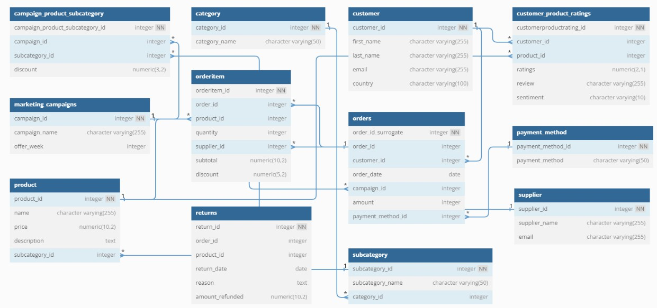**Physical Model:**

# Dimensional Model:

* **Business Processes Being Modeled**
  1. **Sales Transactions** – Capturing product sales by customers over time, including quantities, discounts, and net-revenue.
  2. **Campaign Performance** – Tracking customer engagement or purchases related to marketing campaigns.
  3. **Product Returns** – Capturing information about returned products, reasons, refunded amounts, and quantities.
* **Grain of Each Fact Table**
  1. **Sales Fact Table**

**Grain: very fine:** One record per product per customer per order line item on a specific date.

* 1. **Campaign Performance Fact Table**

**Grain:** One record per customer, per campaign, per subcategory, per date.

**Each row represents:** Aggregated campaign performance metrics like total sales and returns for that customer and campaign context.

* 1. **Returns Fact Table**

**Grain:** One record per product return transaction.

**Each row represents:** A returned item including refund amount, reason, return date, and original order information.

* **Type of Each Fact Table**
  1. **Sales Fact Table**
     + **Type:** Transaction fact table.
     + **Reason:** Records individual sales transactions at the most granular level.
  2. **Campaign Performance Fact Table**
     + **Type:** Periodic snapshot fact table.
     + **Reason:** Aggregates data (orders, sales, discounts, returns) across a period, likely daily, by campaign and customer.
  3. **Returns Fact Table**
     + **Type:** Transaction fact table.
     + **Reason:** Each record corresponds to a specific return event with all transactional details.
* **Dimensions:**

|  |  |
| --- | --- |
| **Dimension Name** | **Dimension Type** |
| D_Date | Role-Playing Dimension |
| D_Customer | Slowly Changing Dimension (SCD) + Conformed Dimension |
| D_PaymentMethod | Static Dimension |
| D_Supplier | Slowly Changing Dimension (SCD) |
| D_Product | Slowly Changing Dimension (SCD) + Conformed Dimension |
| D_return | Junk Dimension |

|  |  |
| --- | --- |
| **Dimension Name** | **Dimension Type** |
| Order_id | Degenerate Dimension |

* **Measures:**

|  |  |  |
| --- | --- | --- |
| **Fact Table** | **Measures** | **Type** |
| Sales Fact | Net Revenue | Fully Additive |
| Returns Fact | Quantity Returned , Processing Days | Fully Additive |
| Campaign Performance | Total quantity ,total sales, net sales | Fully Additive |

* **Physical Model:**

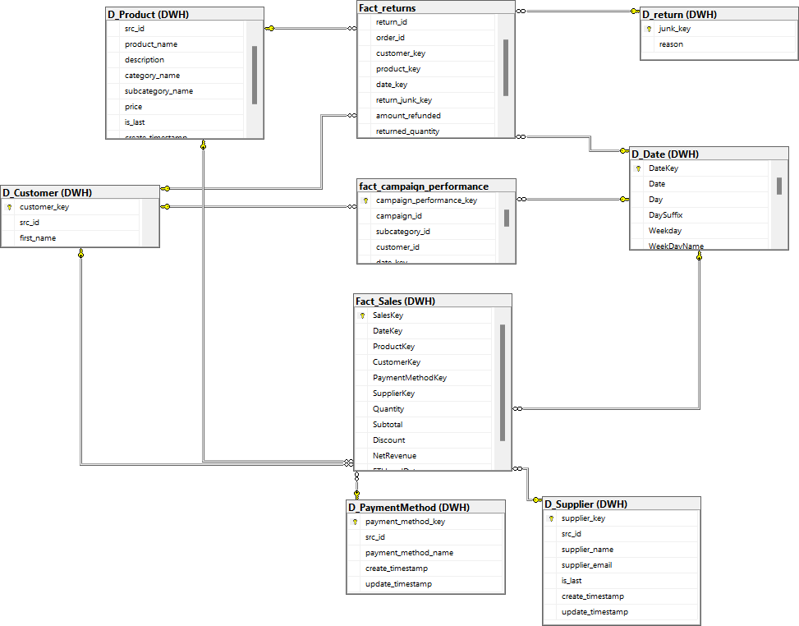

# Control flow C Data flow:

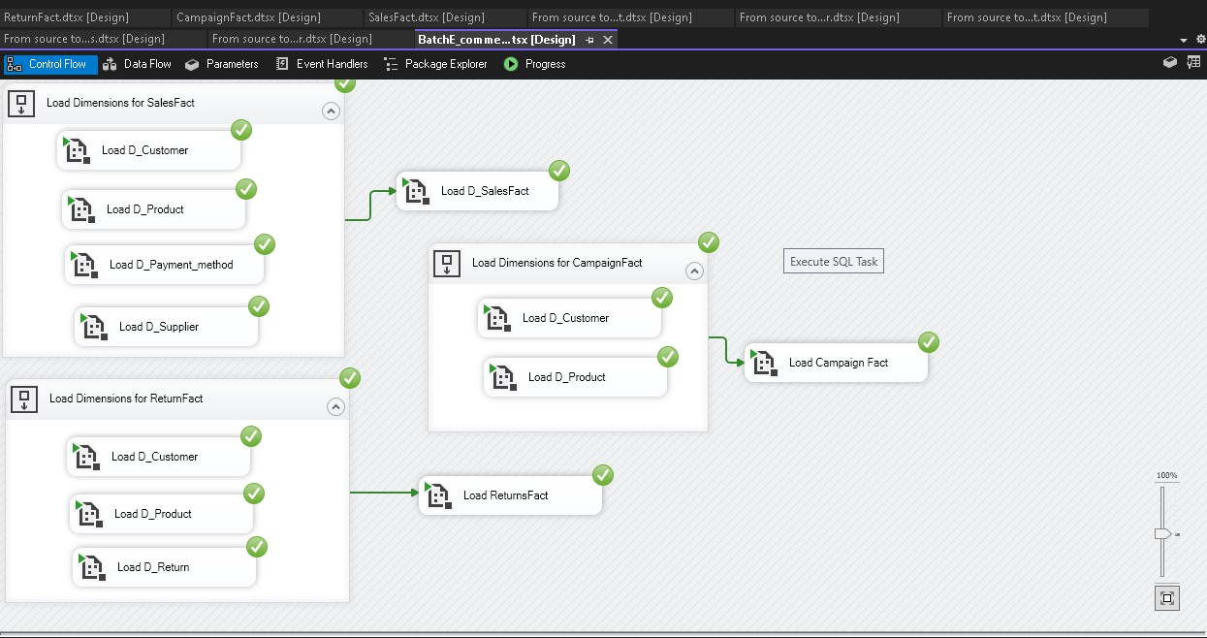

Figure 1 Batch of E-commerce

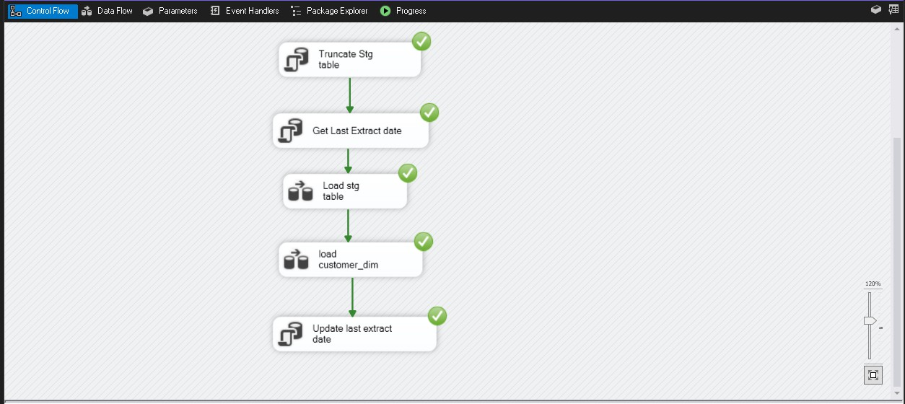

Figure 2 Control Flow of From Source to Customer Dimension

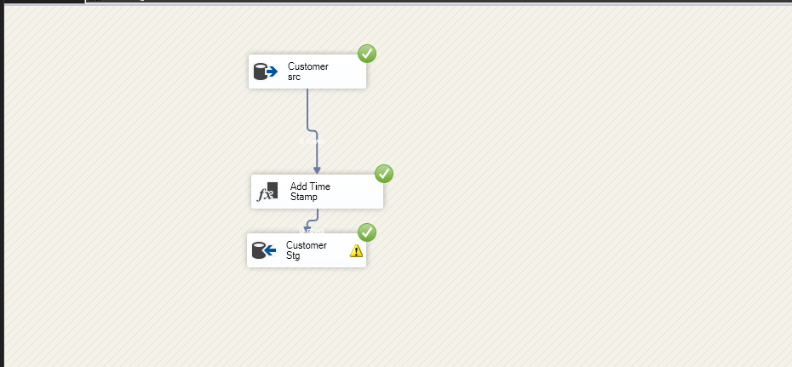

Figure 3 Data Flow of From Source to Customer Dimension (Load Customer Staging Table)

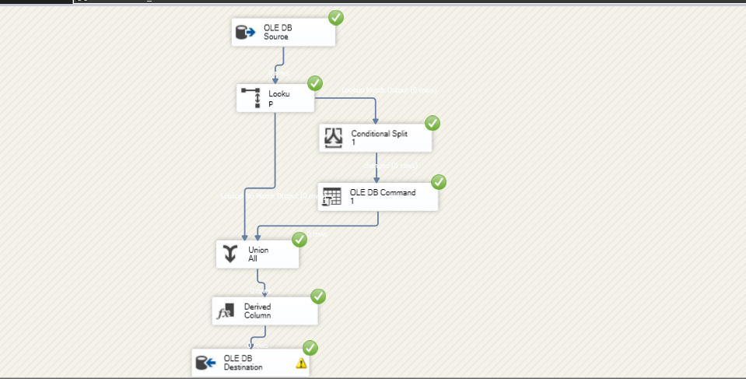

Figure 4 Data Flow of From Source to Customer Dimension (Load Customer Dimension)

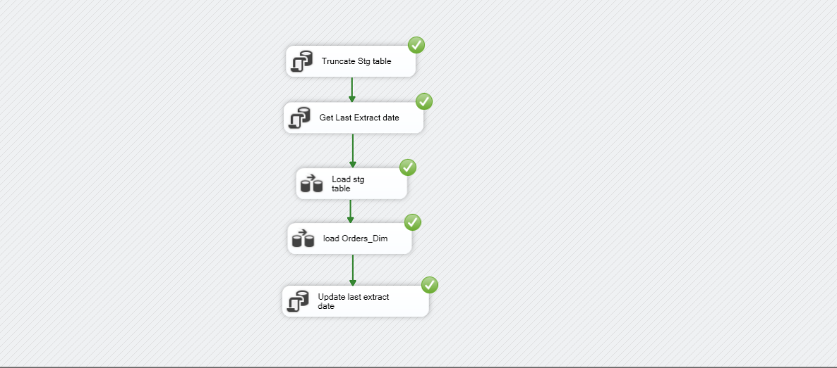

Figure 5 Control Flow of From Source to Orders Dimension

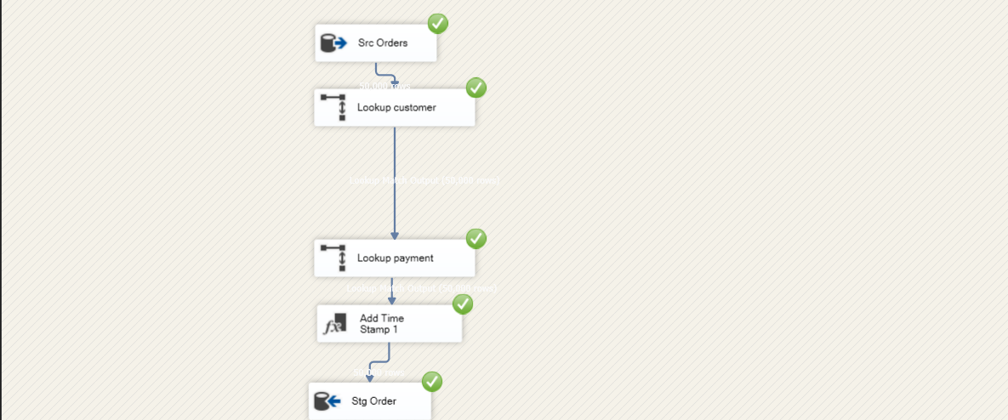

Figure c Data Flow of From Source to Orders Dimension (Load Orders Staging Table)

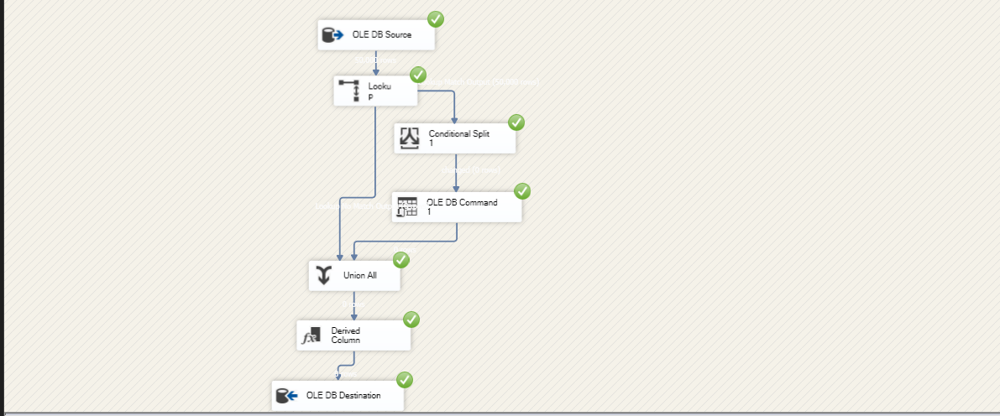

Figure 7 Data Flow of From Source to Orders Dimension (Load Orders Dimension)

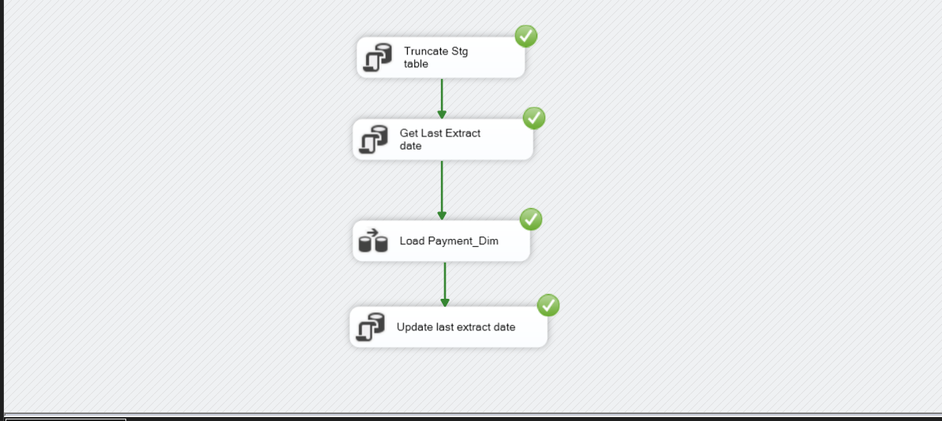

Figure 8 Control Flow of From Source to Payment Method Dimension

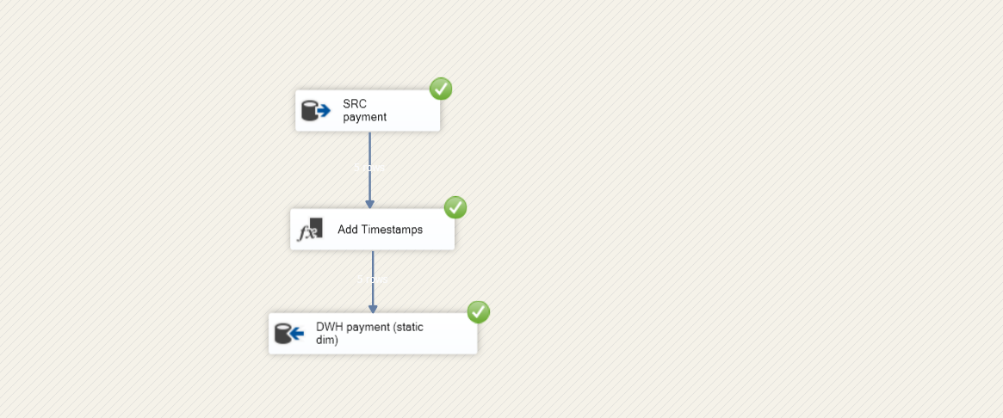

Figure S Data Flow of From Source to Payment Method Dimension (Load Payment Method Dimension)

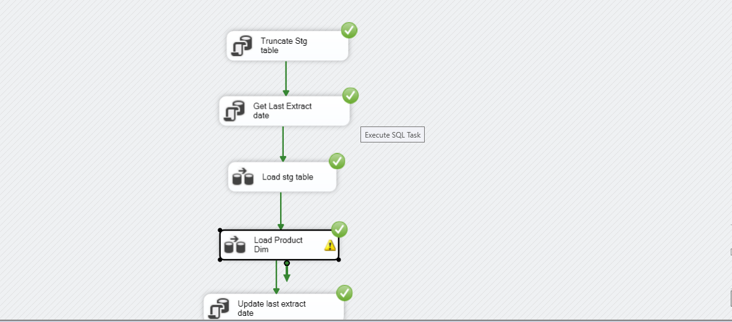

Figure 10 Control Flow of From Source to Product Dimension

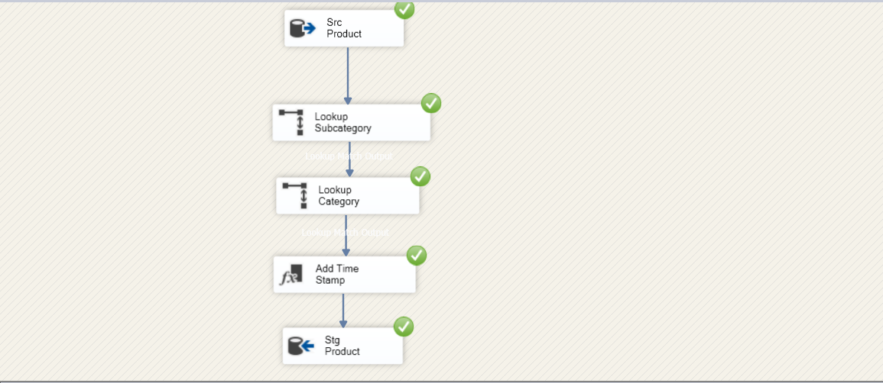

Figure 11 Data Flow of From Source to Product Dimension (Load Product Staging Table)

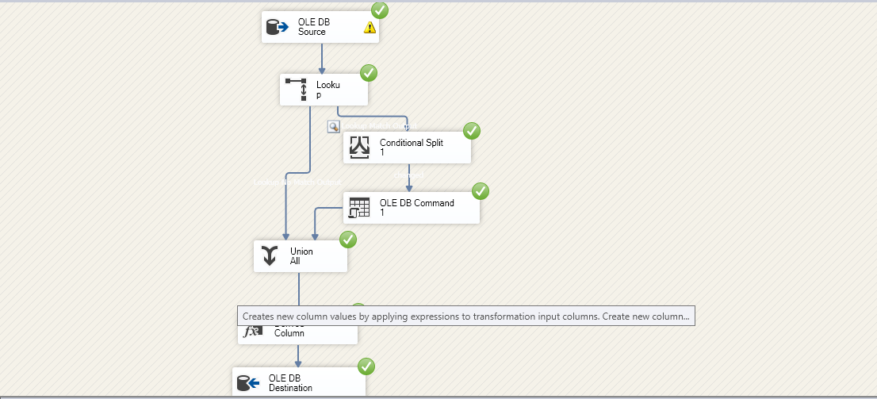

Figure 12 Data Flow of From Source to Product Dimension (Load Product Dimension)

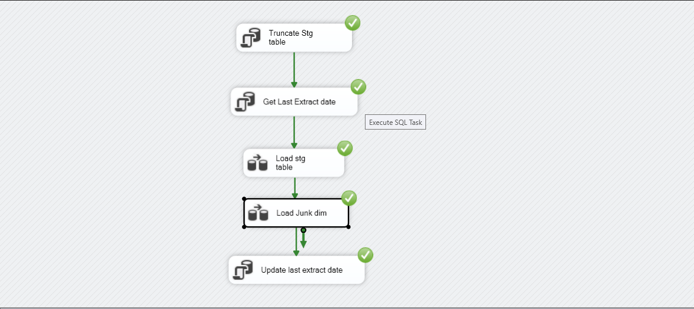

Figure 13 Control Flow of From Source to Returns Dimension

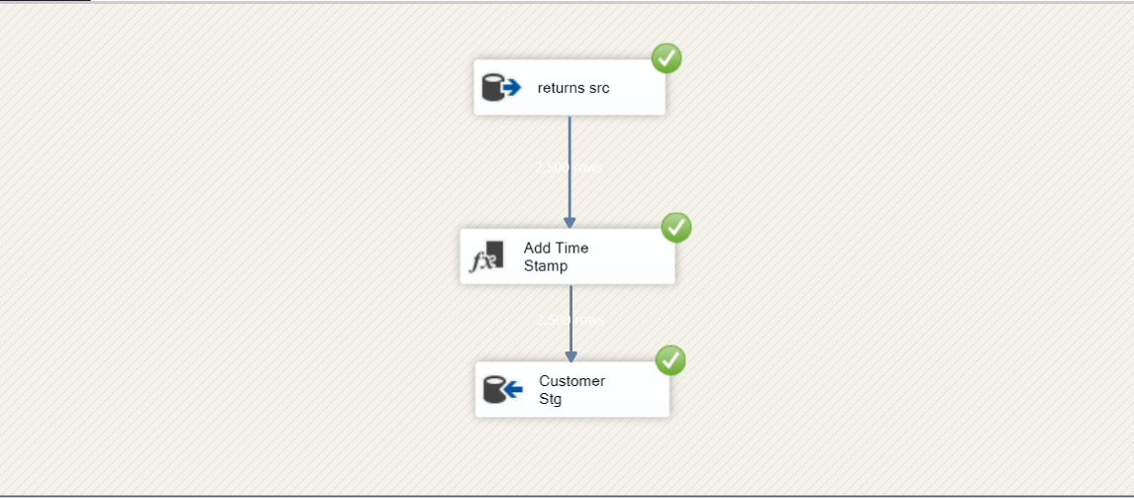

Figure 14 Data Flow of From Source to Returns Dimension (Load Return Staging Table)

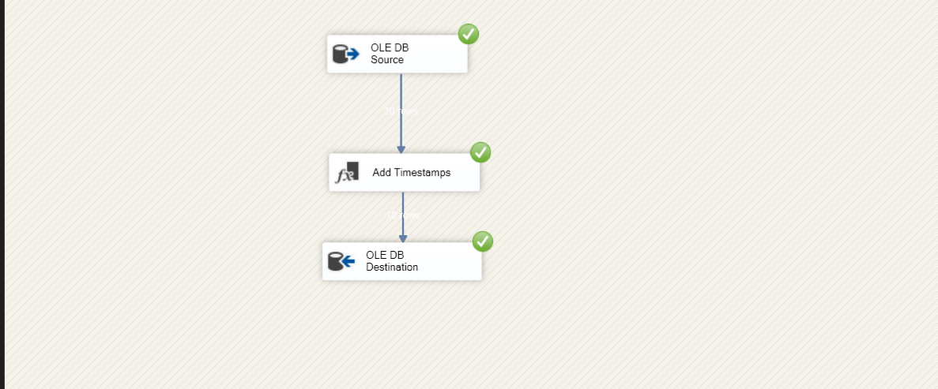

Figure 15 Data Flow of From Source to Returns Dimension (Load Returns Dimension)

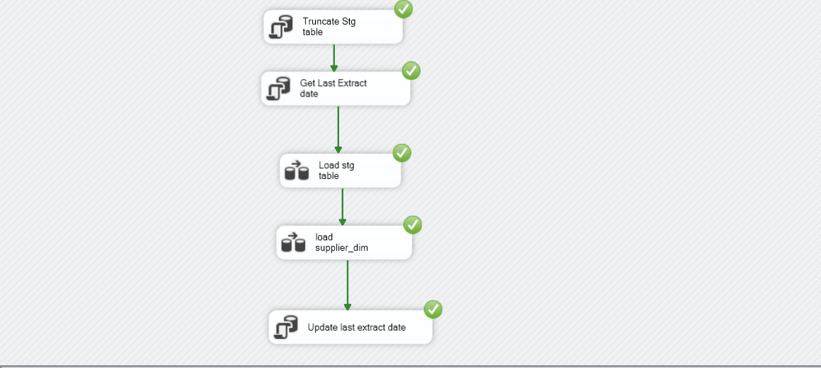

Figure 1c Control Flow of From Source to Supplier Dimension

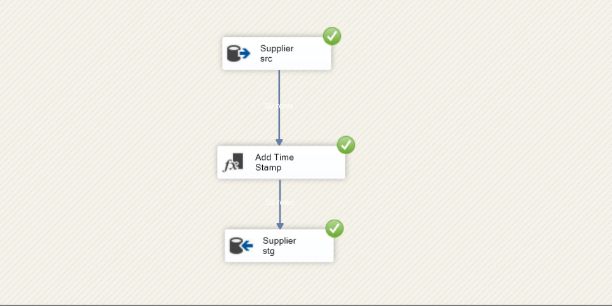

Figure 17 Data Flow of From Source to Supplier Dimension (Load Supplier Staging Table)

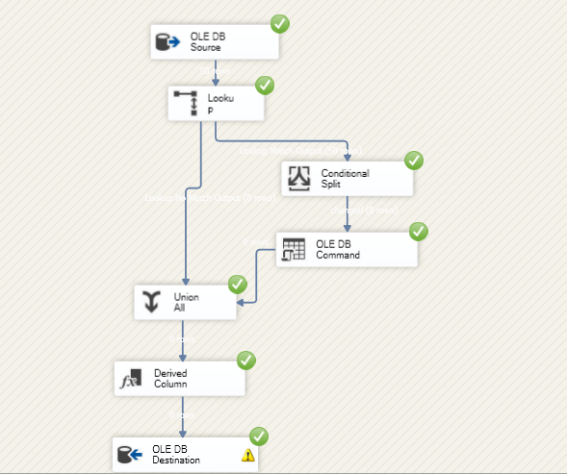

Figure 18 Data Flow of From Source to Supplier Dimension (Load Supplier Dimension)

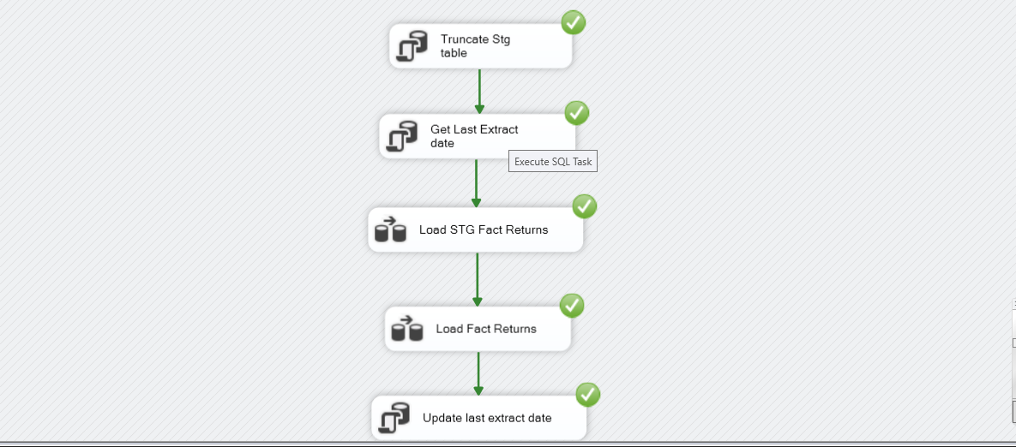

Figure 1S Control Flow of Returns Fact Table

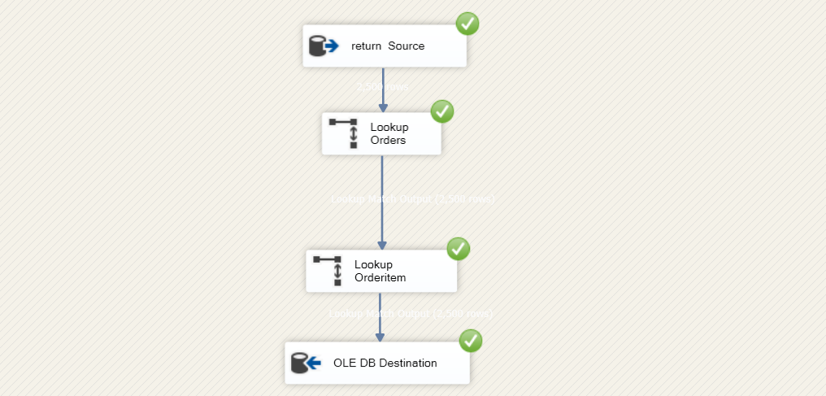

Figure 20 Data Flow of Returns Fact Table (Load Returns Fact Staging Table)

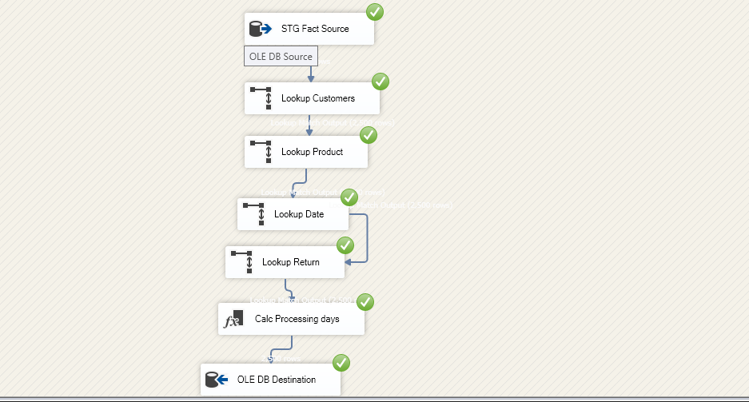

Figure 21 Data Flow of Returns Fact Table (Load Returns Fact Table)

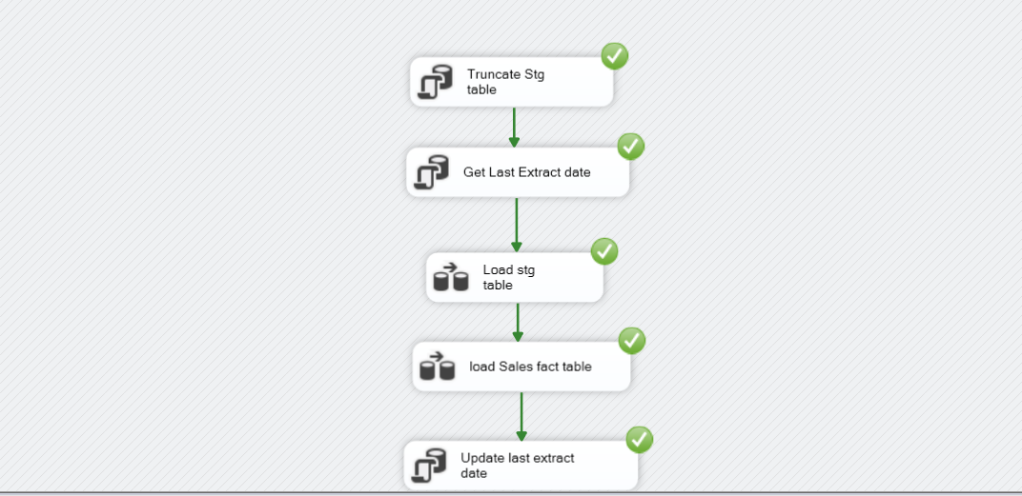

Figure 22 Control Flow of Sales Fact Table

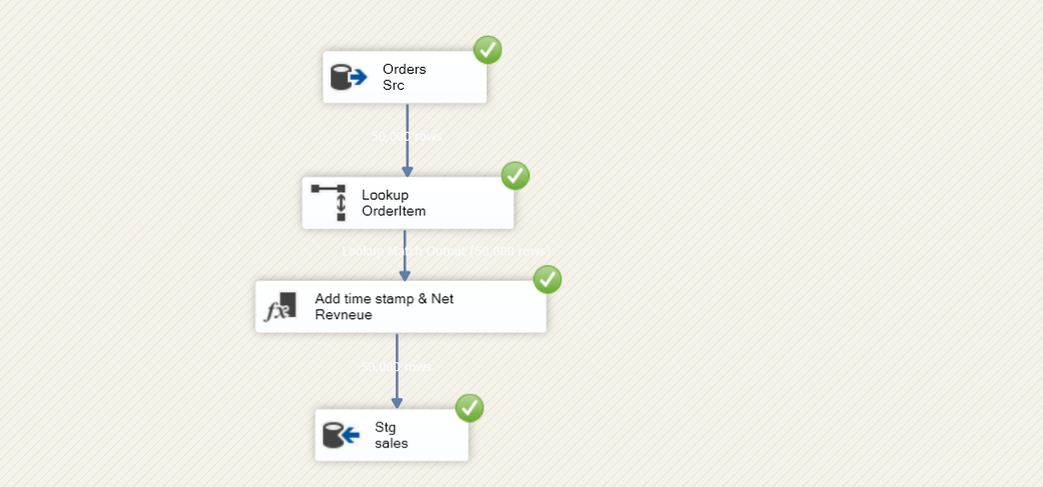

Figure 23 Data Flow of Sales Fact Table (Load Sales Fact Staging Table)

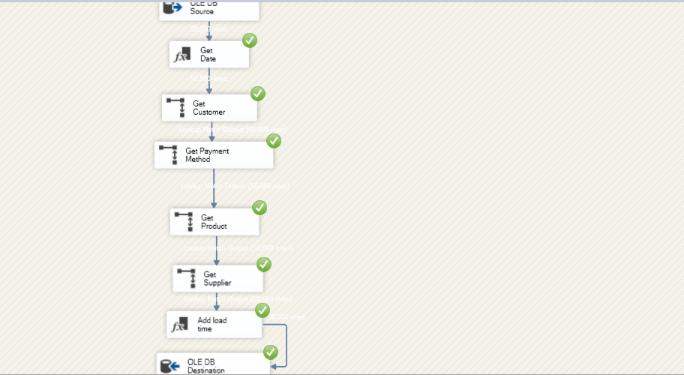

Figure 24 Data Flow of Sales Fact Table (Load Sales Fact Table)

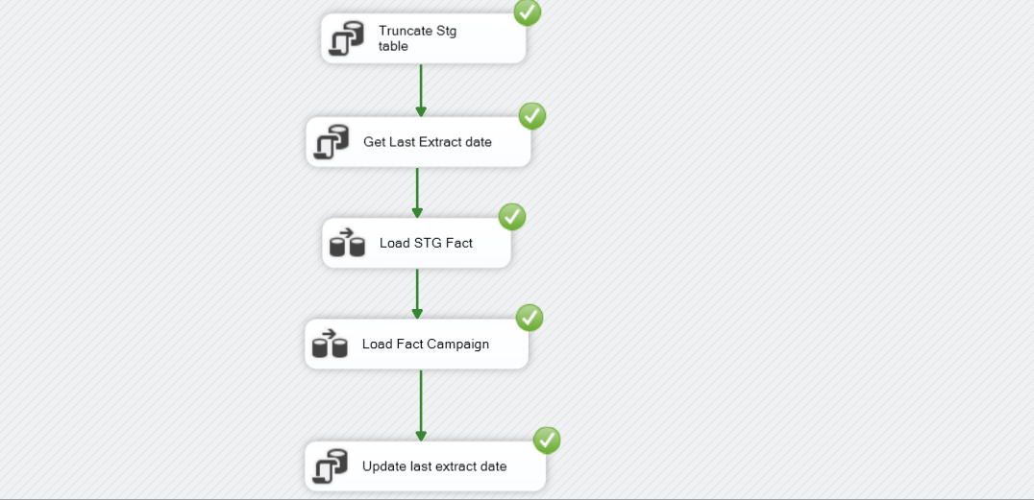

Figure 25 Control Flow of Campaign Performance Fact Table

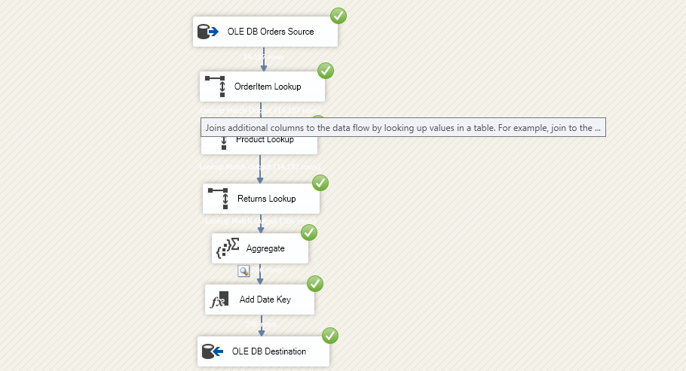

Figure 2c Data Flow of Campaign Performance Fact Table (Load Campaign Performance Fact Staging Table)

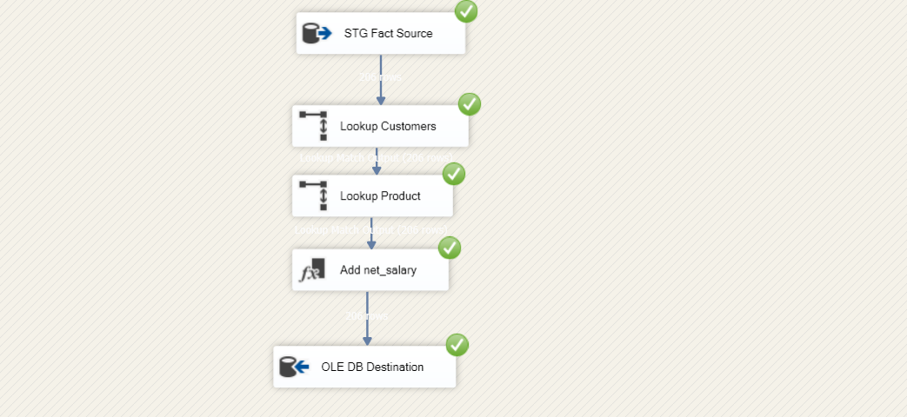

Figure 27 Data Flow of Campaign Performance Fact Table (Load Campaign Performance Fact Table)

# Queries

1. 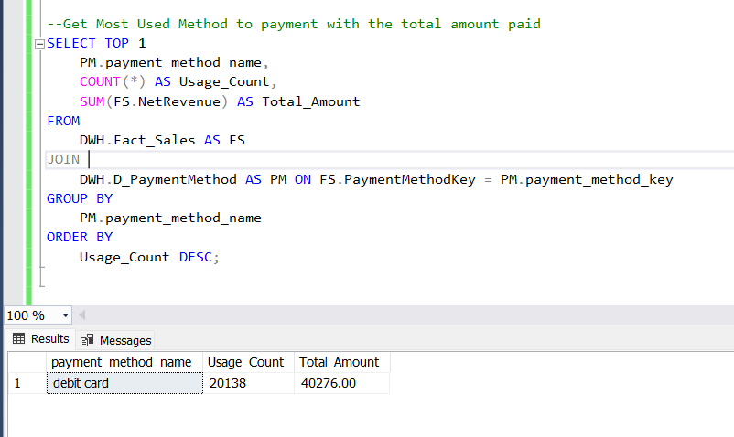Queries on Sales Fact:

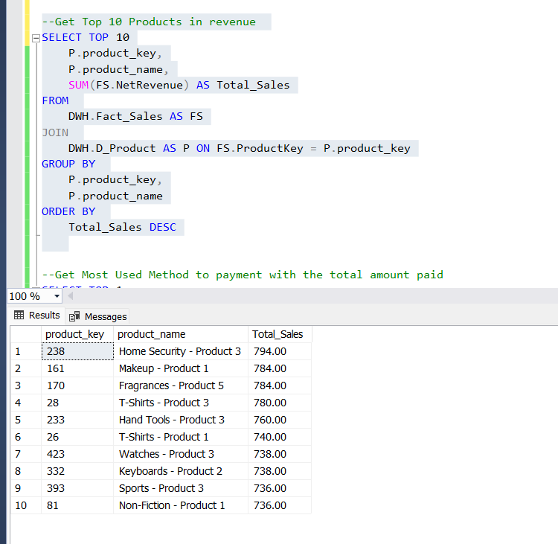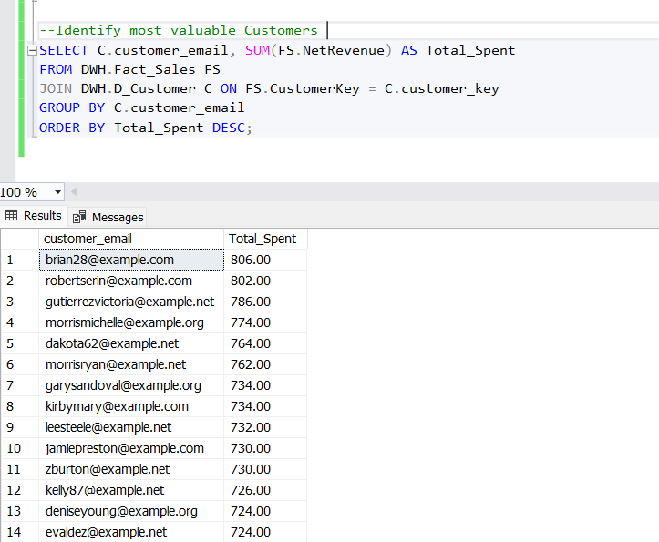

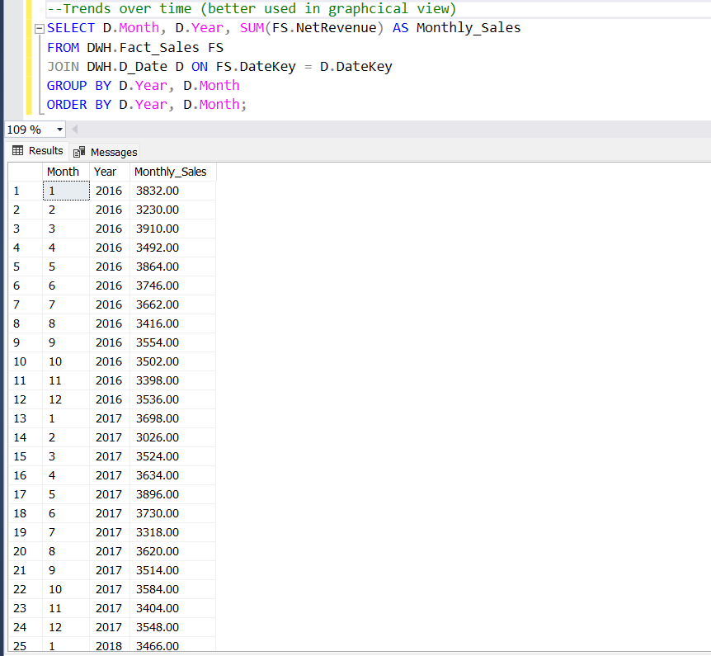

1. Queries on Campaign Performance Fact:

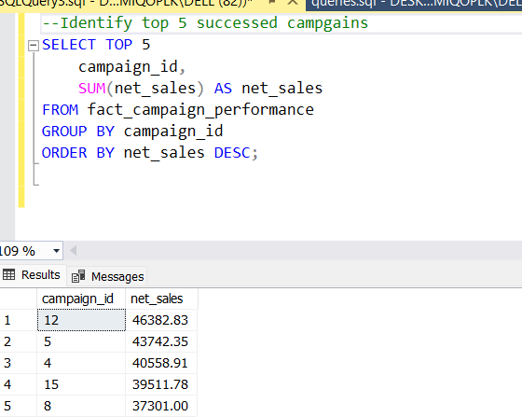

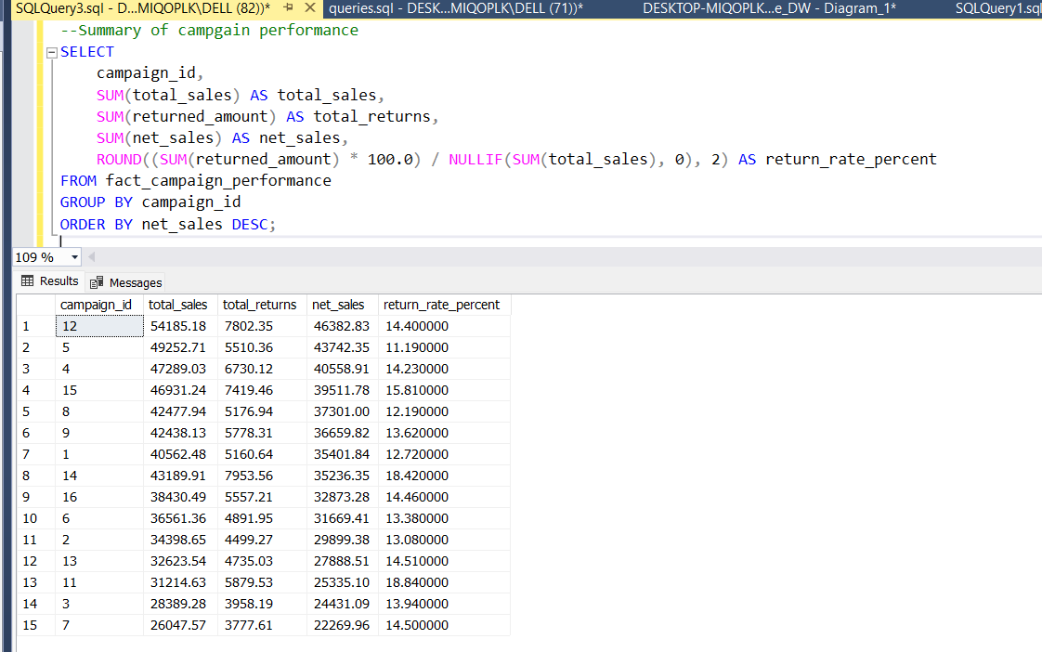

1. Queries on Returns Fact:

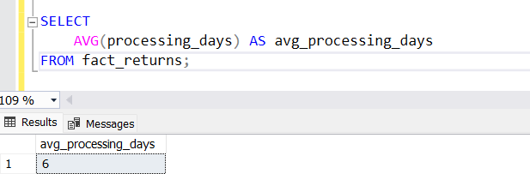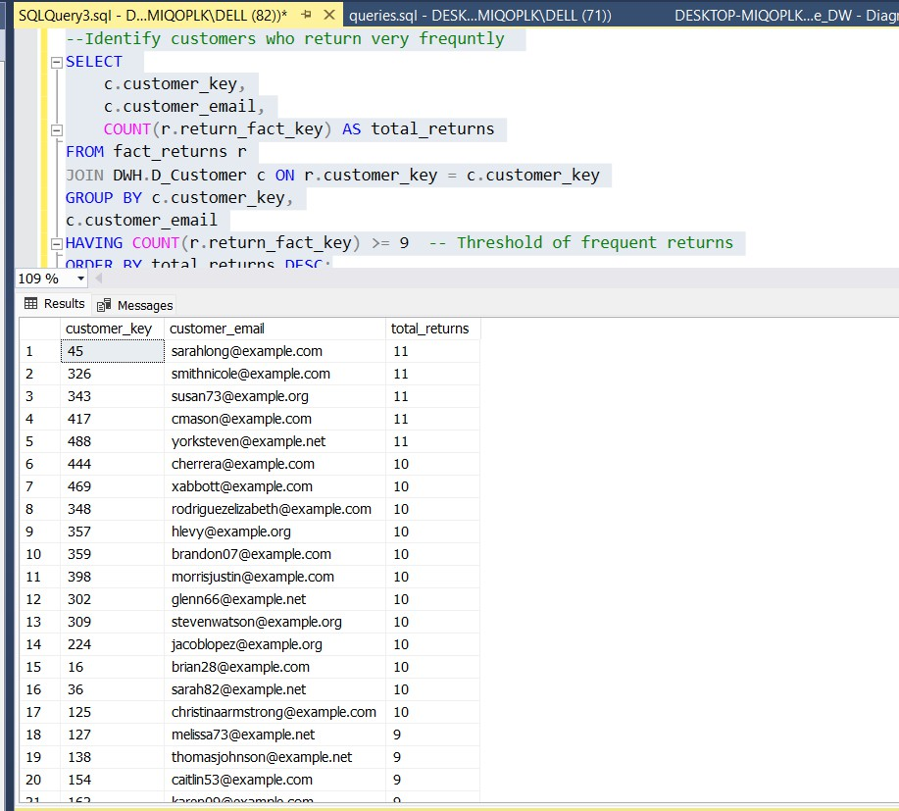

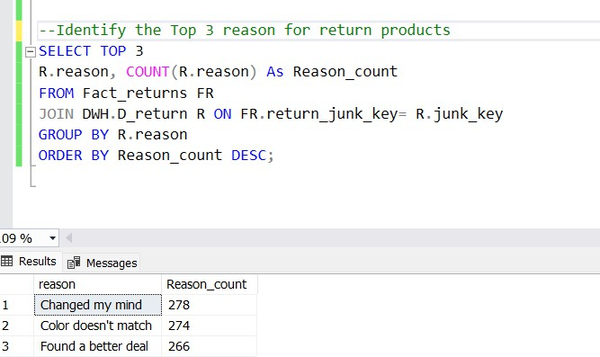

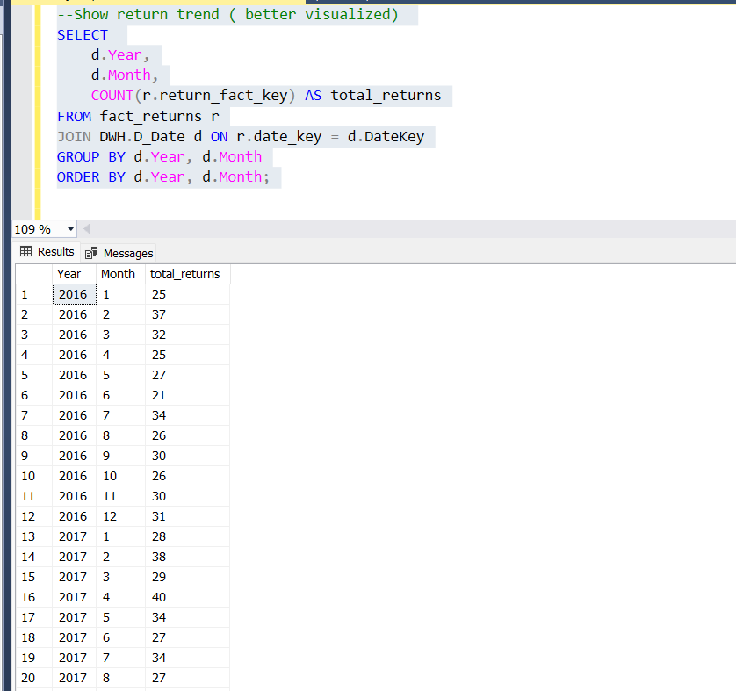

# Deployed Packages:

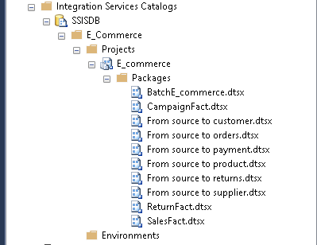

Their Schedules:

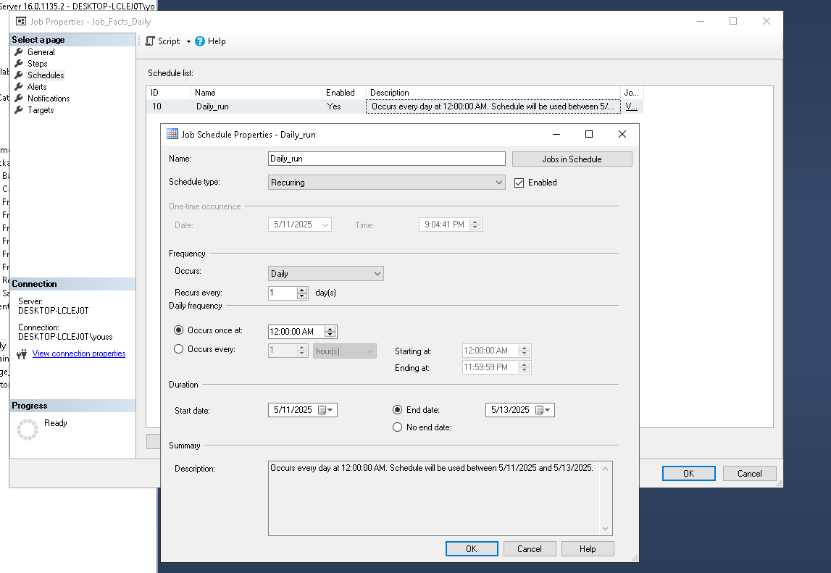

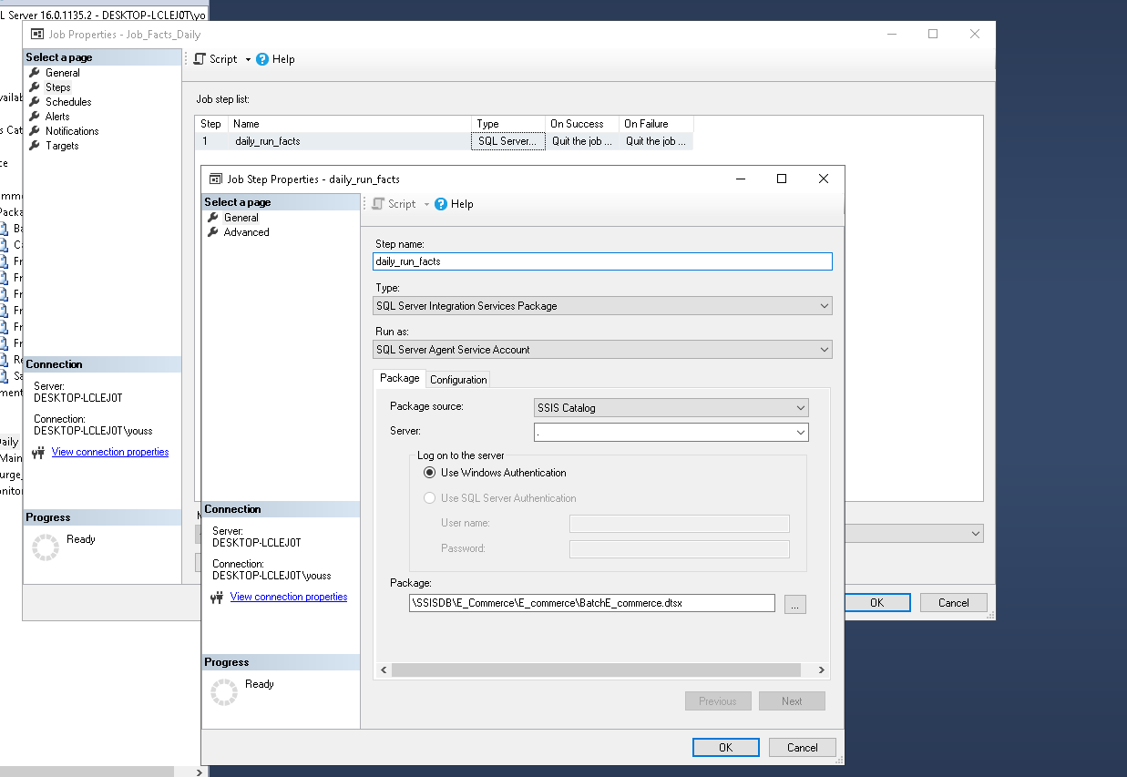

1. 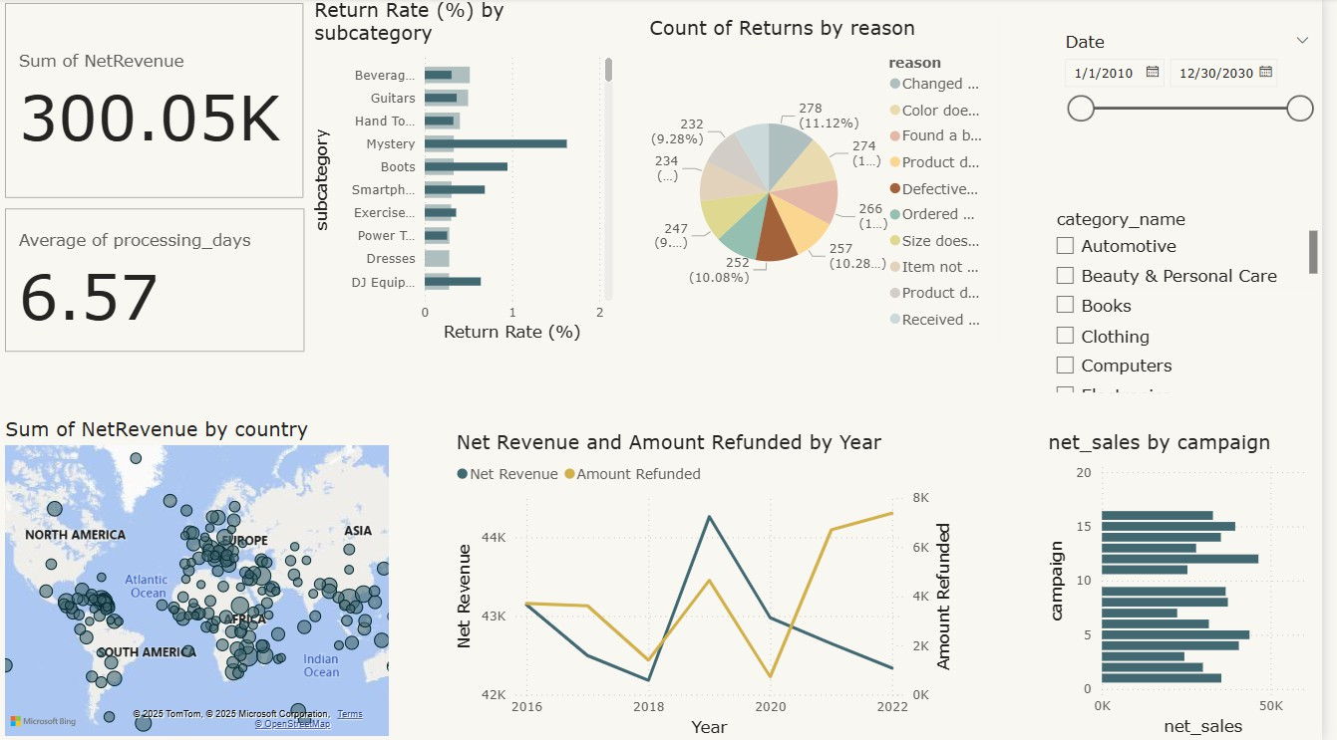Power BI: